

**Project Status Report**



**Project Name: SUSAN ICE STORE ORDERING AND INVENTORY SYSTEM**

**Department:**

**Focus Area:**

**Product/Process:**



**Prepared By:**

|  |  |
| --- | --- |
| **Document Owner(s)** | **Project/Organization Role** |
| Leonard Potian | Project Manager/Programmer |
| Nelaine Valdez | Document Manager/Programmer |
|  |  |

**Project Status Report Version Control**

|  |  |  |  |
| --- | --- | --- | --- |
| **Version** | **Date** | **Author** | **Change Description** |
| 1.0 | 06/18/17 | Leonard Potian | Submission of first status report and vision and scope |
|  |  |  |  |
|  |  |  |  |
|  |  |  |  |

**TABLE OF CONTENTS**

1 PROJECT STATUS REPORT PURPOSE 3

2 PROJECT STATUS REPORT TEMPLATE 3

2.1 Project Status Report Details 3

2.2 Project Status Report Template 3

3 PROJECT STATUS REPORT APPROVALS 3

4 APPENDICES 3

4.1 Document Guidelines 3

4.2 Project Status Report Sections Omitted 3

# PROJECT STATUS REPORT PURPOSE

The purpose of this report is to pass the first status report and to revised our vision and scope document during last term

.



# PROJECT STATUS REPORT TEMPLATE

## Project Status Report Details

This is the first status report where we are required to pass the draft of vision and scope.

* [Status of the Project]
  + Our system is all about ordering and inventory system.
  + We finished our first status report and the first draft of vision and scope

## Project Status Report Template

|  |  |  |
| --- | --- | --- |
| Project Name | | |
| Prepared By:  Leonard Potian | Date:  06/16/2017 | Reporting Period:  06/15/17 to 06/19/17 |
| Project Overall Status:  We are improving and developing our system | | |
| Project Summary:  All documents in CSPOJ last term are in the git-hub and we will improve all the documents. | | |

# 

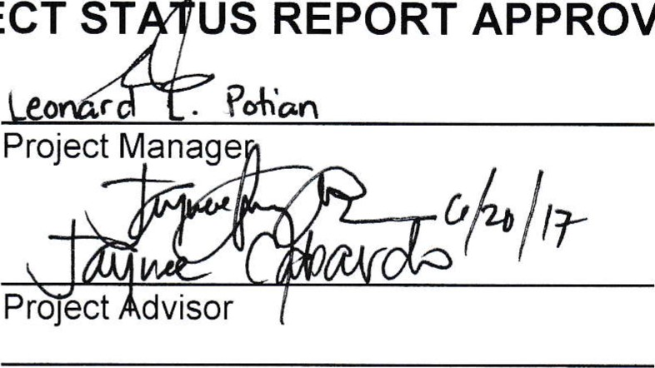

PROJECT

APPROVALS

Client

Sponsor

3

Prepared

by

Approved

by

# APPENDICES

## Document Guidelines

## Project Status Report Sections Omitted

